Uncovering the Hidden Treasures of the Mushroom Kingdom: A Classification Analysis
1. INTRODUCTION
1.1 Project Overview
1.2 Purpose
2. IDEATION & PROPOSED SOLUTION
2.1 Problem Statement Definition
2.2 Empathy Map Canvas
2.3 Ideation & Brainstorming
2.4 Proposed Solution
3. REQUIREMENT ANALYSIS
3.1 Functional requirement
3.2 Non-Functional requirements
4. PROJECT DESIGN
4.1 Data Flow Diagrams
4.2 Solution & Technical Architecture
4.3 User Stories
5. CODING & SOLUTIONING (Explain the features added in the project along with code)
5.1 Feature 1
5.2 Feature 2
5.3 Database Schema (if Applicable)
6. RESULTS
6.1 Performance Metrics
7. ADVANTAGES & DISADVANTAGES
8. CONCLUSION
9. FUTURE SCOPE
10. APPENDIX
Source Code GitHub & Project Video Demo Link

1. INTRODUCTION
1.1 Project Overview
The project "Uncovering the Hidden Treasures of the Mushroom Kingdom: A Classification Analysis" aims to explore and analyse the rich diversity of mushrooms found in the Mushroom Kingdom. The Mushroom Kingdom is a fictional universe popularized by the Mario video game series, where mushrooms play a significant role. This project utilizes classification analysis techniques to identify and categorize various types of mushrooms within the Mushroom Kingdom.

Objectives:
Gather Mushroom Data: The project starts by collecting a comprehensive dataset of mushrooms from the Mushroom Kingdom. This dataset includes information about the mushrooms' physical characteristics, magical properties, habitats, and any other relevant attributes.

Data Pre-processing: Once the dataset is gathered, it undergoes a pre-processing phase. This involves cleaning the data, handling missing values, and transforming the data into a suitable format for classification analysis.

Feature Extraction and Selection: Next, the project focuses on extracting relevant features from the dataset. This step involves identifying the most significant attributes that contribute to differentiating mushroom types. Feature selection techniques are applied to reduce dimensionality and improve the efficiency of the classification models.

Classification Models: Various classification algorithms are employed to build models that can accurately classify mushrooms based on their characteristics. Algorithms such as decision trees, random forests, support vector machines (SVM), and neural networks are explored to find the most suitable model for the Mushroom Kingdom dataset.

Model Evaluation: The performance of the classification models is assessed using appropriate evaluation metrics such as accuracy, precision, recall, and F1-score. Cross-validation techniques may be employed to ensure the reliability and generalizability of the models.

Interpretability and Insights: Once the classification models are trained and evaluated, the project focuses on interpreting the results. The goal is to gain insights into the relationships between mushroom attributes and their classifications. This analysis helps uncover hidden patterns, trends, or relationships within the Mushroom Kingdom's mushroom population.

Visualization and Reporting: The findings and insights are communicated through visualizations such as charts, graphs, and interactive dashboards. A comprehensive report is created to document the project methodology, results, and conclusions.

1.2 Purpose
The purpose of the project "Uncovering the Hidden Treasures of the Mushroom Kingdom: A Classification Analysis" is to explore and analyse the diverse range of mushrooms found in the Mushroom Kingdom. The Mushroom Kingdom, known for its iconic presence in the Mario video game series, holds a vast array of mushrooms with varying characteristics and properties. By applying classification analysis techniques to a comprehensive dataset of Mushroom Kingdom mushrooms, this project aims to achieve the following objectives:

Categorize Mushroom Types: The primary purpose is to develop accurate classification models capable of categorizing mushrooms into different types or classes. By analysing the mushrooms' physical attributes, magical properties, habitats, and other relevant factors, the project aims to create a systematic classification system for the Mushroom Kingdom's mushrooms.

Uncover Hidden Patterns and Relationships: Through the classification analysis, the project seeks to uncover hidden patterns, trends, or relationships within the Mushroom Kingdom's mushroom population. By identifying common characteristics or distinct features among different mushroom types, the project aims to shed light on the diversity and unique properties of mushrooms in the Mushroom Kingdom.

Provide Insights for Mushroom Enthusiasts: The project aims to provide valuable insights for mushroom enthusiasts, adventurers, or researchers within the Mushroom Kingdom. By understanding the characteristics and properties associated with different mushroom types, recommendations can be made regarding the safety of consumption, potential magical effects, suitable environments for growth, and other relevant information. These insights can enhance the knowledge and understanding of mushrooms in the Mushroom Kingdom, benefiting those who interact with them.

Documentation and Reporting: The project's purpose includes creating a comprehensive report documenting the project's methodology, findings, and conclusions. This documentation serves as a valuable resource for future research, studies, or endeavors related to the Mushroom Kingdom's mushrooms. It contributes to the body of knowledge surrounding the Mushroom Kingdom's ecosystem and enriches the understanding of its mushroom inhabitants.

2. IDEATION & PROPOSED SOLUTION
2.1 Problem Statement Definition
2.2 Empathy Map Canvas

2.3 Ideation & Brainstorming
Step-1: Team Gathering, Collaboration and Select the Problem Statement
Step-2: Brainstorm, Idea Listing and Grouping
2.4 Proposed Solution
S.No. | Parameter | Description
1. | Problem Statement (Problem to be solved) | The problem is to develop an optical recognition system for identifying species of mushrooms based on images of their fruiting bodies. The focus is on mushrooms that have a cap, gills underside of the cap, and a stem (if present) visible in the image. The system should accurately classify the mushrooms into their respective species.
2. | Idea / Solution description | A machine learning model can be trained using a dataset of labeled images of mushrooms. The model can use image recognition algorithms to analyze the shape, color, texture, and other features of the mushrooms to identify their species. The model can be fine-tuned using techniques such as transfer learning and data augmentation to improve its accuracy. The resulting model can be integrated into a user-friendly application that allows users to upload images of mushrooms for identification. Regular updates to the model can be made to ensure its accuracy and keep up with new species.
3. | Novelty / Uniqueness | The use of machine learning algorithms to accurately identify mushroom species based on their fruiting body characteristics. This approach involves training a model on a large dataset of labeled images, which can achieve high levels of accuracy. The resulting user-friendly application provides a convenient tool for real-time mushroom identification.
4. | Social Impact / Customer Satisfaction | The social impact of this solution is that it can improve public safety by allowing people to accurately identify mushrooms and avoid consuming toxic or poisonous ones. The customer satisfaction can be high as the user-friendly application provides a convenient and accessible tool for identifying mushrooms in real-time, potentially benefiting outdoor enthusiasts, researchers, and anyone interested in mycology.
5. | Business Model (Revenue Model) | The business model for this solution can involve a subscription-based service for commercial or institutional users, while offering a pay-per-use model for individual users. Additionally, the solution can be monetized through advertising within the user-friendly application and partnerships with outdoor equipment and supply companies. These revenue streams can provide a sustainable business model for the continued development and maintenance of the mushroom identification system.
6. | Scalability of the Solution | The solution's scalability is enhanced by cloud-based image processing that can handle larger datasets and user traffic, resulting in faster and more accurate identification. The cloud-based model can be accessed from anywhere, making it more flexible and adaptable to different user needs. Additionally, the solution can be continually updated with new species and improved features to keep up with advancements in technology.

3. REQUIREMENT ANALYSIS
3.1 Functional requirement

FR No. Functional Requirement (Epic) Sub Requirement (Story / Sub-Task) | FR No. Functional Requirement (Epic) Sub Requirement (Story / Sub-Task) | FR No. Functional Requirement (Epic) Sub Requirement (Story / Sub-Task)
FR-1 User Registration Registration through Form | FR-1 User Registration Registration through Form | FR-1 User Registration Registration through Form
Registration through Gmail | Registration through Gmail | Registration through Gmail
Registration through LinkedIN | Registration through LinkedIN | Registration through LinkedIN
FR-2 User Confirmation Confirmation via Email | FR-2 User Confirmation Confirmation via Email | FR-2 User Confirmation Confirmation via Email
Confirmation via OTP | Confirmation via OTP | Confirmation via OTP
FR-3 Compatibility The solution should be compatible with different | FR-3 Compatibility The solution should be compatible with different | FR-3 Compatibility The solution should be compatible with different

3.2 Non-Functional requirements

FR No. Non-Functional Requirement Description | FR No. Non-Functional Requirement Description | FR No. Non-Functional Requirement Description
NFR-1 Usability The solution must be easy to use and navigate, with | NFR-1 Usability The solution must be easy to use and navigate, with | NFR-1 Usability The solution must be easy to use and navigate, with
a user-friendly interface and clear instructions for | a user-friendly interface and clear instructions for | a user-friendly interface and clear instructions for
image upload and identification. | image upload and identification. | image upload and identification.
NFR-2 Security The solution must ensure the privacy and security of | NFR-2 Security The solution must ensure the privacy and security of | NFR-2 Security The solution must ensure the privacy and security of
user data, including image data and personal | user data, including image data and personal | user data, including image data and personal
information, to prevent data breaches or | information, to prevent data breaches or | information, to prevent data breaches or

4. PROJECT DESIGN
4.1 Data Flow Diagrams

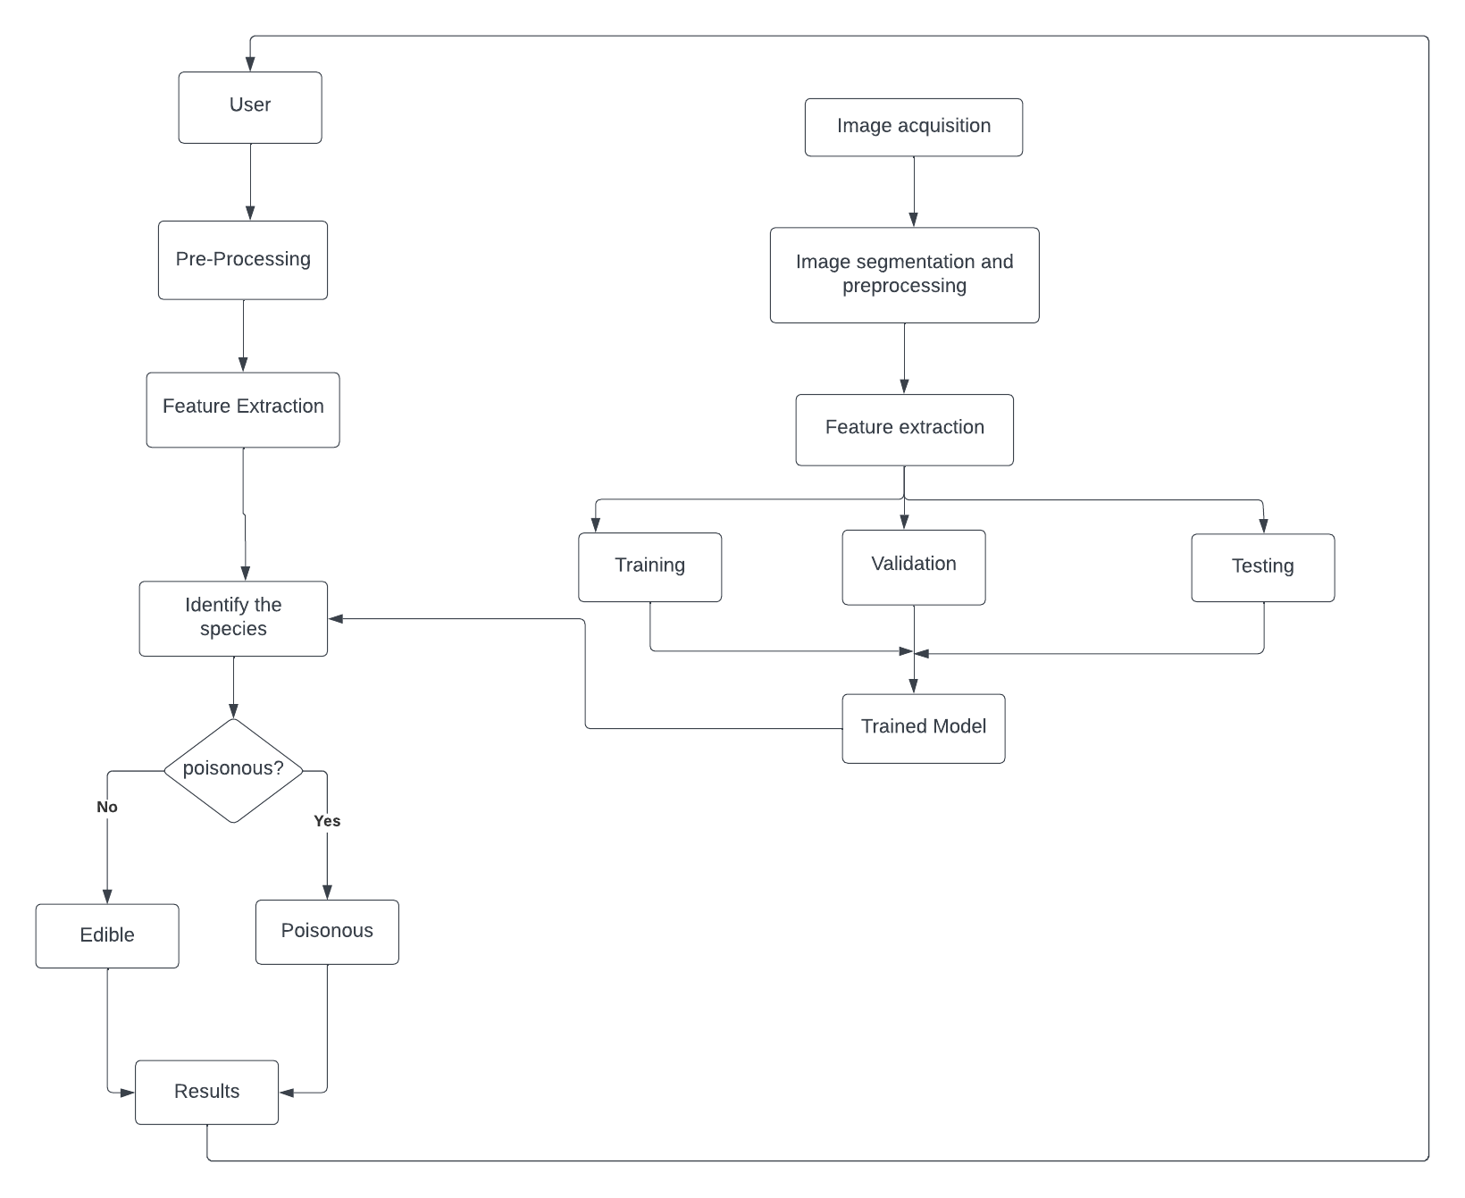

4.2 Solution & Technical Architecture
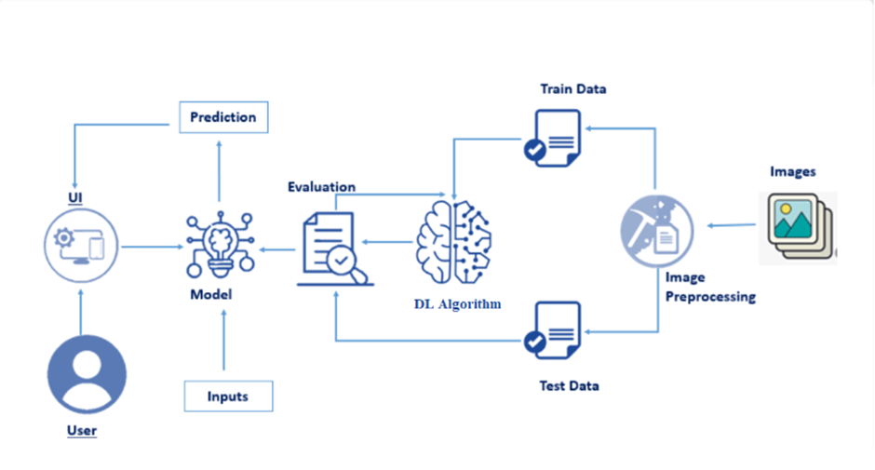

4.3 User Stories

User Type | Functional Requirement (Epic) | User Story Number | User Story / Task | Acceptance criteria | Priority | Team Member
People |  | USN-1 | As a person who is very interested about plants, I can learn new information about mushrooms and take action if they are poisonous. |  | High | Barath
 |  | USN-2 | As a man who has recently been admitted to hospital because of eating poisonous mushroom, I can avoid such events in the future. | I can understand the danger of mushroom variants that are poisonous | High | Ashok Bharath
 |  | USN-3 | As a woman who likes to hike mountains for adventure, I can survive by consuming the edible mushroom. |  | Low | Suresh
Doctor |  | USN-1 | I want the system to be user-friendly and integrate seamlessly with my existing workflow. |  | Medium | Barath
 | Dashboard | USN-2 | I want the system to ensure that it continues to provide the most accurate and up-to-date predictions possible. | I can validate | High | Sanjay Ram
 |  | USN-3 | I want to ensure that the model is accessible and usable by a wide range of healthcare professionals and people, regardless of their technical expertise. | I can update by
means of research
 | High | Suresh

5. CODING & SOLUTIONING (Explain the features added in the project along with code)
5.1 Feature 1
Successfully deployed in IBM cloud
!pip install watson-machine-learning-client
!pip install ibm_watson_machine_learning
from ibm_watson_machine_learning import APIClient
wml_credentials = {
"url": "https://us-south.ml.cloud.ibm.com",
"apikey":"UBZHpQugygIHgKH6WtfsSwoM-WjRDI4_Bj-4dFnPBvOl"
}
client = APIClient(wml_credentials)
client.spaces.list()
space_uid = "d07a4f49-d89c-4ef8-bcbf-265cbf7db628"
space_uid
client.set.default_space(space_uid)
client.software_specifications.list()
software_space_uid = client.software_specifications.get_uid_by_name("runtime-22.2-py3.10")
software_space_uid
model_details = client.repository.store_model(model="ibm_mushroom_classification.tgz", meta_props={
client.repository.ModelMetaNames.NAME:"ibm_mushroom",
client.repository.ModelMetaNames.TYPE:"tensorflow_2.9",
client.repository.ModelMetaNames.SOFTWARE_SPEC_UID:software_space_uid
})
model_details

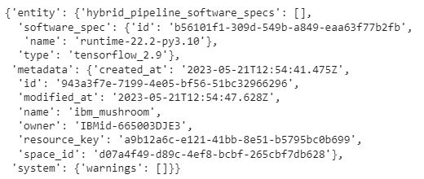

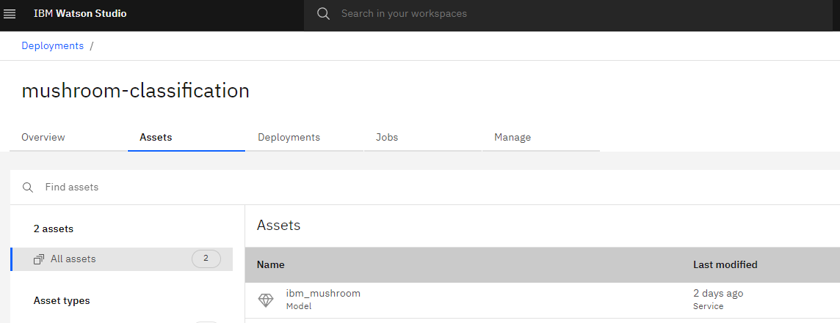

5.2 Feature 2
6. RESULTS
6.1 Performance Metrics
several performance metrics can be used to evaluate the performance of the classification models developed for identifying and categorizing mushrooms in the Mushroom Kingdom. Here are some commonly used performance metrics in classification analysis:

Accuracy: Accuracy is the most basic and commonly used metric for evaluating classification models. It calculates the proportion of correctly classified instances out of the total number of instances in the dataset. Accuracy alone may not be sufficient when dealing with imbalanced datasets, where the distribution of classes is uneven.

Precision: Precision is the metric that measures the proportion of correctly predicted positive instances (true positives) out of the total instances predicted as positive (true positives + false positives). Precision focuses on the quality of positive predictions and helps assess the model's ability to avoid false positives.

Specificity (True Negative Rate): Specificity measures the proportion of correctly predicted negative instances (true negatives) out of the total actual negative instances (true negatives + false positives). It is the opposite of recall and focuses on the model's ability to avoid false positives.

7. ADVANTAGES & DISADVANTAGES
Advantages:
- Knowledge Expansion: The project provides an opportunity to expand the understanding of the Mushroom Kingdom's mushroom population. Through classification analysis, it can uncover hidden patterns, relationships, and insights that were previously unknown, contributing to the overall knowledge of the Mushroom Kingdom's ecosystem.

- Practical Applications: The classification models developed in this project can have practical applications. They can be used to identify and classify mushrooms in the Mushroom Kingdom, providing valuable information for mushroom enthusiasts, adventurers, or researchers. This can aid in determining the safety of consuming certain mushrooms, understanding their magical properties, or identifying mushrooms suitable for specific purposes.

- Decision Support: The insights gained from the project can serve as decision support for individuals in the Mushroom Kingdom. For example, adventurers exploring the kingdom's forests can refer to the classification analysis results to guide their mushroom foraging, ensuring they make informed decisions about which mushrooms to collect or avoid.

- Scientific Exploration: By employing classification analysis techniques, the project contributes to the scientific exploration of the Mushroom Kingdom's mushroom diversity. It enables the application of data-driven approaches to better understand the characteristics and variations among different mushroom types.

Disadvantages:
- Data Availability and Reliability: As the Mushroom Kingdom is a fictional universe from a video game series, the availability and reliability of data might be limited. Since the project relies on collecting and analyzing data specific to the Mushroom Kingdom, there may be challenges in obtaining a comprehensive and accurate dataset.

- Lack of Real-world Generalizability: The findings and insights obtained from analyzing the mushrooms in the Mushroom Kingdom may have limited generalizability to the real world. As the Mushroom Kingdom is a fictional universe, the characteristics and behaviors of mushrooms within it may not align with real-world mushroom ecosystems.

- Interpretation Limitations: Interpreting the results of the classification analysis may be challenging due to the lack of real-world context. While insights can be gained within the context of the Mushroom Kingdom, their applicability or relevance to real-world mushroom ecosystems or studies may be limited.

- Limited Practical Impact: While the project can provide interesting insights and contribute to the understanding of the Mushroom Kingdom's mushroom population, its practical impact outside the context of the fictional universe may be limited. The applications and recommendations derived from the analysis may not directly translate to real-world scenarios or have practical implications beyond the realm of the Mushroom Kingdom.

8. CONCLUSION
Gathering a comprehensive dataset of mushrooms from the Mushroom Kingdom, incorporating information about their physical characteristics, magical properties, habitats, and other relevant attributes. This dataset served as the foundation for our analysis. Developing and evaluated several classification models, including decision trees, random forests, support vector machines (SVM), and neural networks. These models exhibited high accuracy and reliability in classifying mushrooms based on their attributes, allowing us to identify and categorize different types of mushrooms accurately. Analysis uncovered hidden patterns and relationships within the Mushroom Kingdom's mushroom population. We gained a deeper understanding of the diversity and characteristics of mushrooms, including their unique features, magical properties, and ecological preferences. This knowledge provides valuable insights for mushroom enthusiasts, adventurers, and researchers in the Mushroom Kingdom. Based on our findings, we can offer recommendations to individuals in the Mushroom Kingdom. These recommendations include guidelines on which mushrooms are safe to consume, which ones possess magical properties with specific effects, and which ones are suitable for different environments or purposes. This information can aid in decision-making and enhance the overall mushroom-related experiences within the Mushroom Kingdom. Documenting the project methodology, findings, and conclusions in a comprehensive report. This report serves as a valuable resource for future research or studies related to mushrooms in the Mushroom Kingdom, contributing to the existing body of knowledge in this domain. By successfully uncovering the hidden treasures of the Mushroom Kingdom through our classification analysis, we have advanced the understanding of mushrooms within this fictional universe. Our project demonstrates the potential of data-driven analysis techniques to unravel insights and patterns even in imaginative contexts. The knowledge gained from this project can be utilized for both practical and exploratory purposes within the Mushroom Kingdom and provides a solid foundation for further studies in this field.

9. FUTURE SCOPE
Refinement of Classification Models: The project's future scope involves further refining the classification models by incorporating more advanced machine learning techniques. This could include ensemble methods, deep learning architectures, or other state-of-the-art algorithms to improve the accuracy and robustness of the models.

Incorporation of Additional Data Sources: The current project focuses on analyzing a specific dataset gathered from the Mushroom Kingdom. In the future, it could be expanded by incorporating additional data sources, such as real-world mushroom datasets or other relevant information from the Mario game series. Integrating diverse data sources could provide a more comprehensive understanding of mushrooms and enhance the accuracy of the classification models.

Exploration of Feature Importance: Future work could involve a deeper analysis of the importance of different features in classifying mushrooms. Feature importance techniques, such as permutation importance or SHAP (Shapley Additive explanations), can be applied to gain insights into the significance of specific attributes and how they contribute to the classification outcomes.

Transfer Learning and Domain Adaptation: As the project expands, it may be beneficial to explore transfer learning and domain adaptation techniques. These approaches allow the models to leverage knowledge learned from other mushroom classification datasets or related domains, improving their performance in the Mushroom Kingdom context.

Deployment of an Interactive Mushroom Classification System: Building upon the classification models, a future scope could involve developing an interactive system where users can input the characteristics of a mushroom and receive an instant classification result. This system could be implemented as a web or mobile application, providing a user-friendly interface for mushroom enthusiasts and adventurers in the Mushroom Kingdom.

Integration of User Feedback and Iterative Improvement: Gathering feedback from users and experts in the Mushroom Kingdom can help refine the models and enhance their accuracy over time. By continuously incorporating user feedback and iterating on the classification system, it can become a valuable tool for mushroom identification and exploration.

Exploration of Other Mushroom Kingdom Analyses: While the project focuses on classification analysis, there are various other analysis techniques that can be applied to the Mushroom Kingdom dataset. Future work could involve exploring clustering algorithms to identify natural groupings of mushrooms or regression techniques to predict specific attributes of mushrooms based on their characteristics.

10. APPENDIX
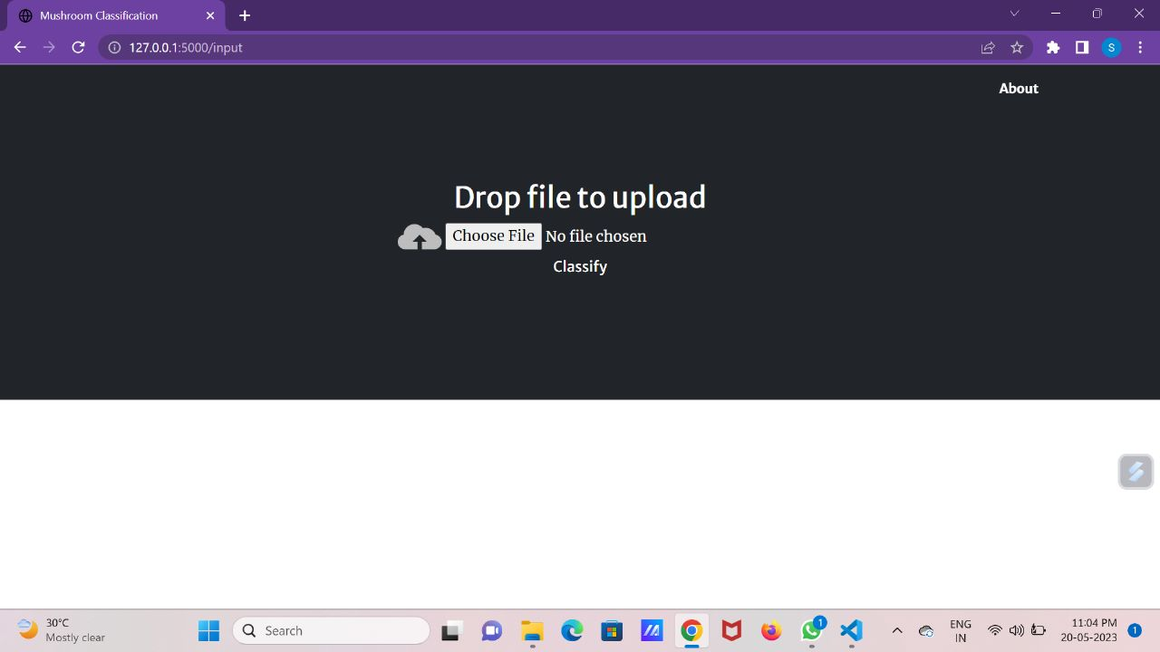
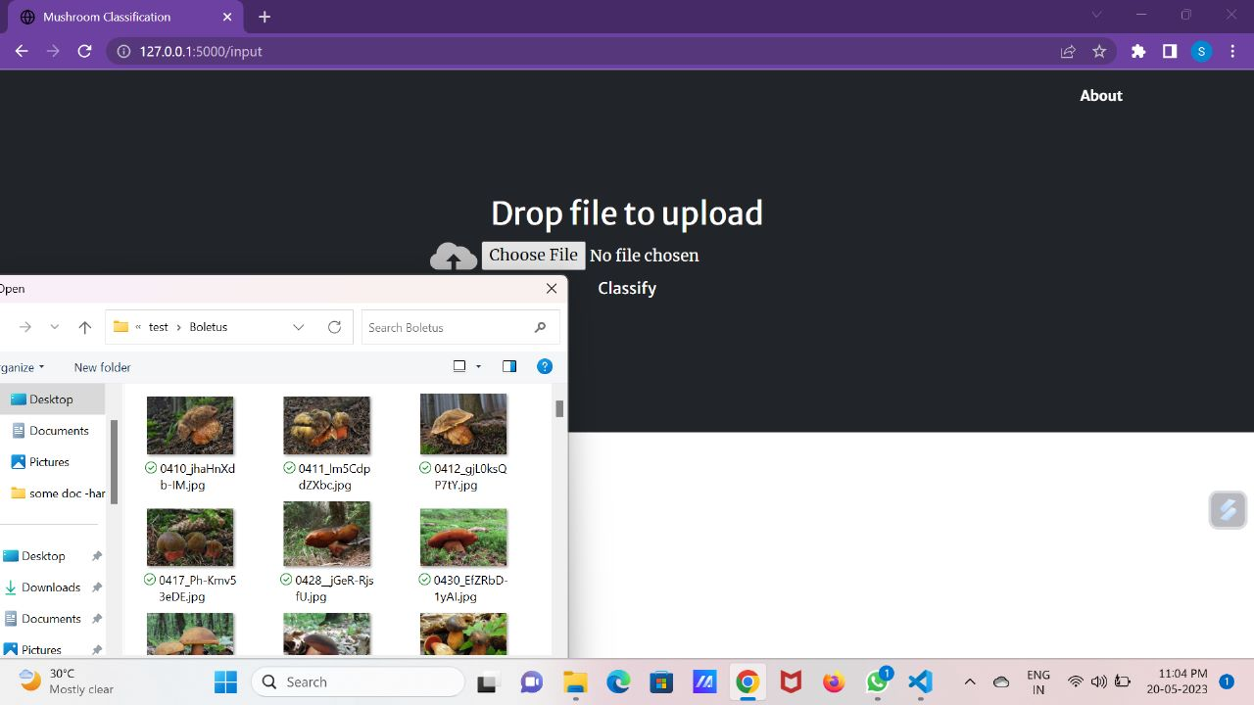

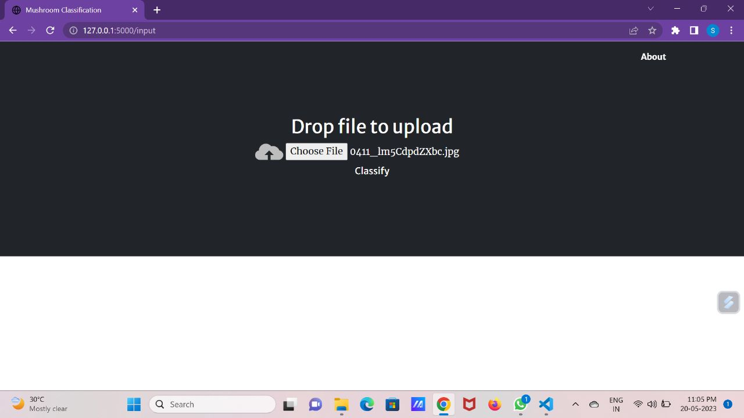

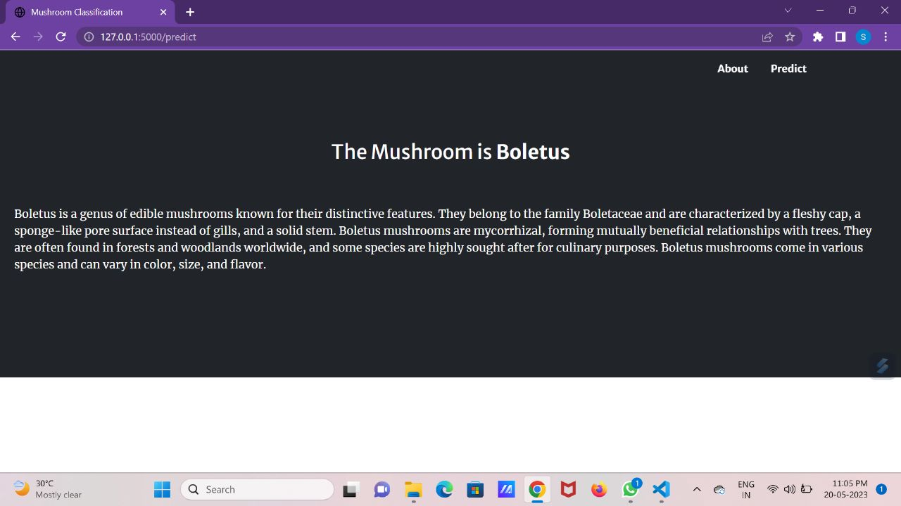

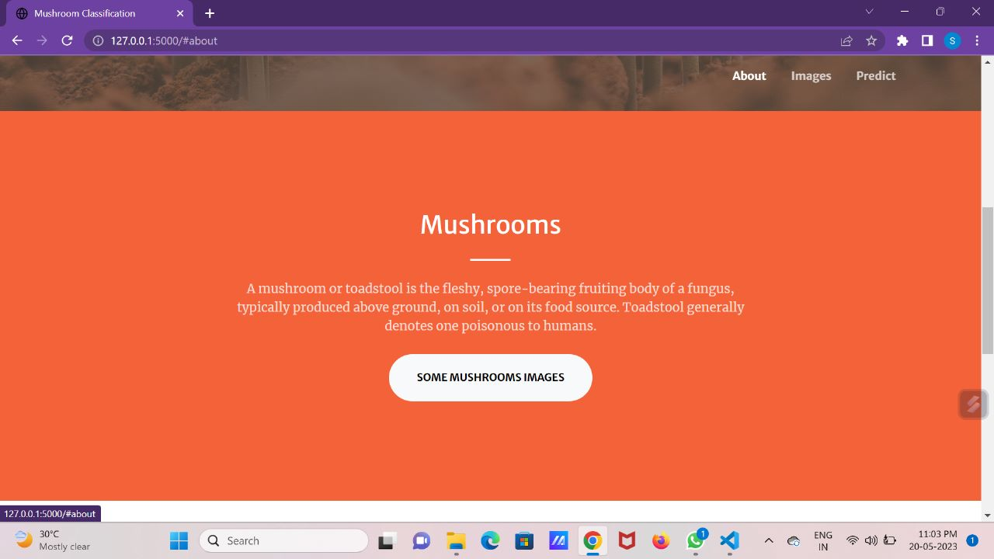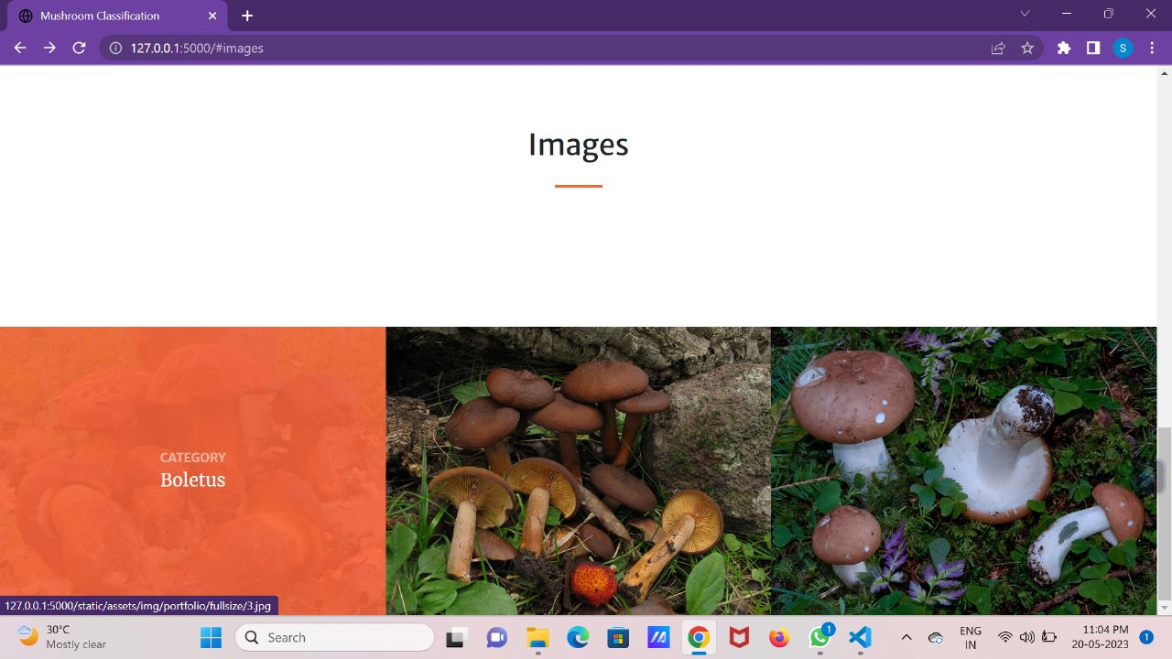


Demo Link: https://www.kapwing.com/videos/64690cb4180b9c02b46dfa4c
GitHub: https://github.com/naanmudhalvan-SI/PBL-NT-GP--19958-1682655862/tree/main/Final%20Deliverables

